Technical Datasheet of WIN-PiHAT-8DO(MOSFET)
1. Overview
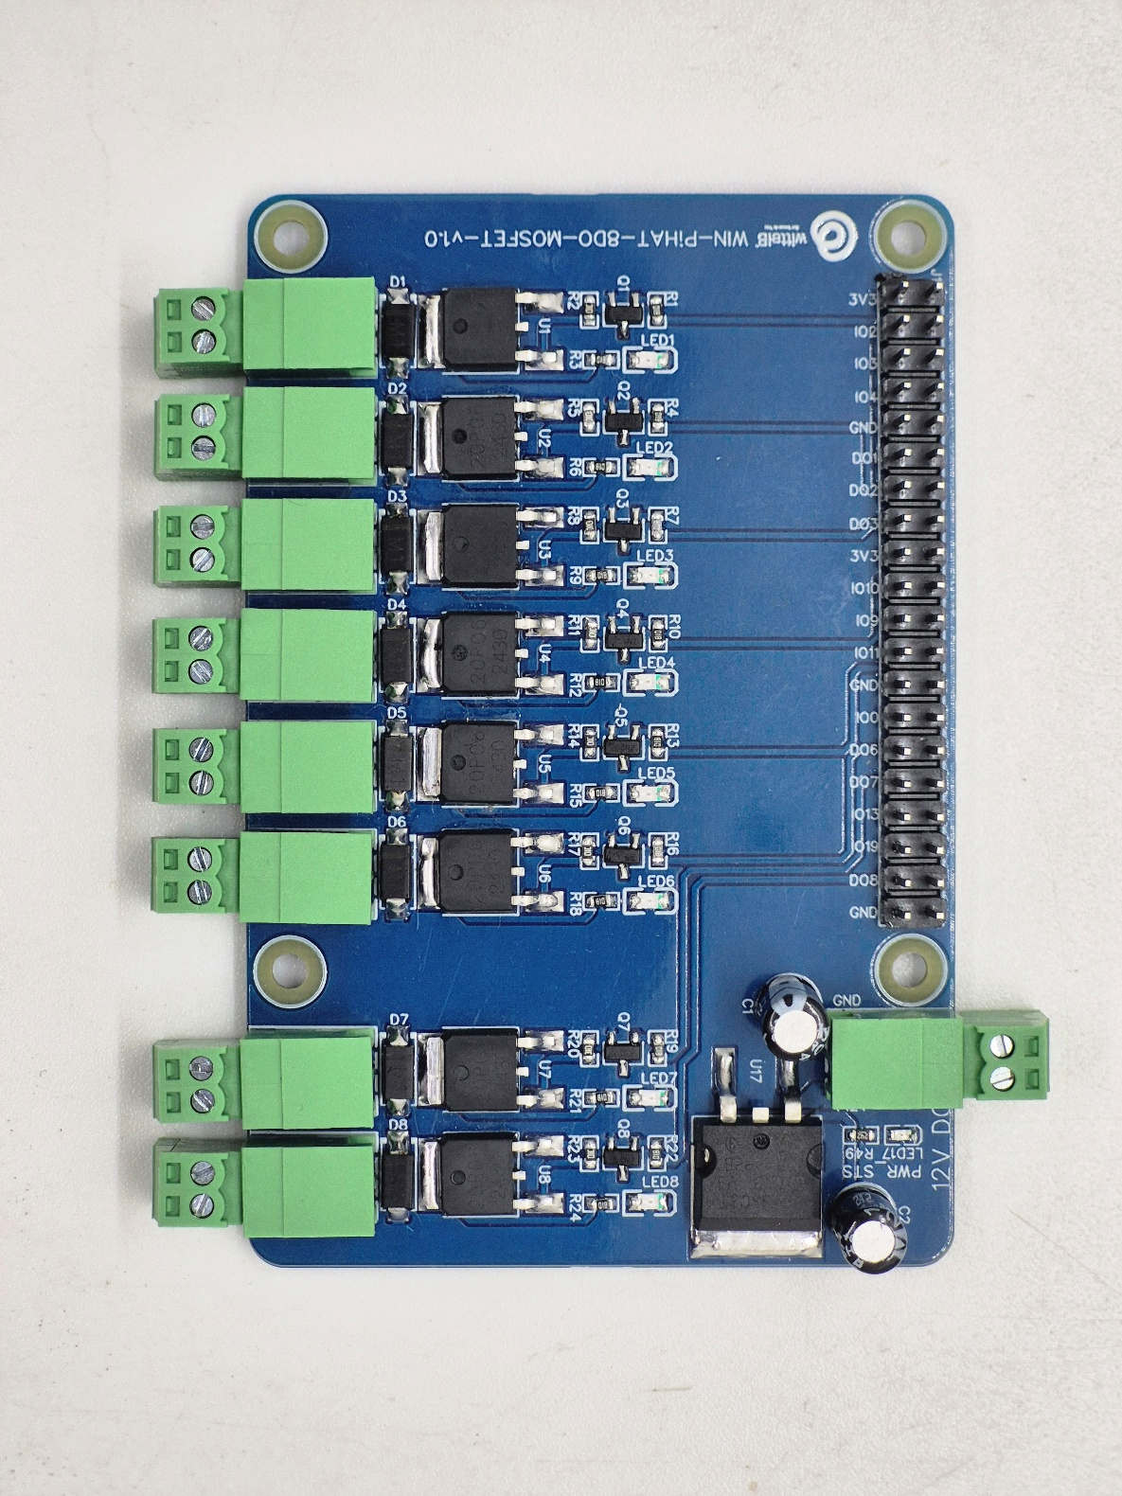
The Digital Output (DO) (MOSFET) PiHAT is an 8-channel expansion board for Raspberry Pi 4 and CM4, offering MOSFET-based digital output for industrial load control. The MOSFET-based output stage protects your system by providing level shifting and load buffering between external loads and the Pi’s GPIO header, ensuring reliable operation in industrial environments.

PiHAT features a scalable architecture supporting 1 to 8 independent MOSFET digital outputs (DO). Its population-based design allows channel flexibility while maintaining a compact and reliable solution for embedded control, automation, and industrial load switching applications.
Specifications
Category | 8DO(MOSFET) PiHAT
Output Type | Solid-State Digital Outputs (High-Side),  P-Channel MOSFET, 2A @ 12VDC
Channel Count | 8 Channels (Expandable Design Architecture)
Connectors | 9 of 2.54 mm Pluggable Terminal Blocks (2-Pin),  40-Pin Raspberry Pi GPIO Header
General :–

Dimensions 56 mm L x 85 mm W
Power Input Power – 12/24V DC
Operating Temperature 0 – 60° C (32 ~ 140°F)
Storage Temperature -20 - 70° C (-4 ~ 158°F)
Storage Humidity 5 ~ 95 % RH, non – Condensing
Certifications 

DO (Digital Outputs) with Relay :–

Channels 8
Output Type High-Side Switch (P-MOSFET)
Max Load Current 2A Continuous (per channel)
Switching Voltage 12V - 24V DC
Switching Time (On/Off) < 100 µs
On Resistance < 100 Ω
Operation Life Virtually Unlimited (Solid-State)
Protection Integrated Flyback Diode

Configuration :-

All 8 DO channels operate as MOSFET-driven digital outputs and are interfaced to the Raspberry Pi GPIO header through a Bipolar Transistor (BJT) driver stage. Output control is performed via software running on the Raspberry Pi. Each channel is configured as a GPIO output and drives a corresponding High-Side MOSFET switch.

When a GPIO pin is driven HIGH, the Bipolar Transistor pulls the MOSFET Gate LOW, turning the channel ON and supplying power to the load. When the GPIO pin is driven LOW, the MOSFET turns OFF and the output returns to its default state.

The following are step by step guides for configuration:
- Connect the Module to +12/24V DC POWER SUPPLY.
- Connect the Board to the Raspberry Pi via header pins

Sr. No. | Digital Input | Pi GPIO | Header Pin number
1 | D01 | 17 | 11
2 | D02 | 27 | 13
3 | D03 | 22 | 15
4 | D04 | 24 | 18
5 | D05 | 25 | 22
6 | D06 | 05 | 29
7 | D07 | 06 | 31
8 | D08 | 26 | 37

Wiring Diagram:-
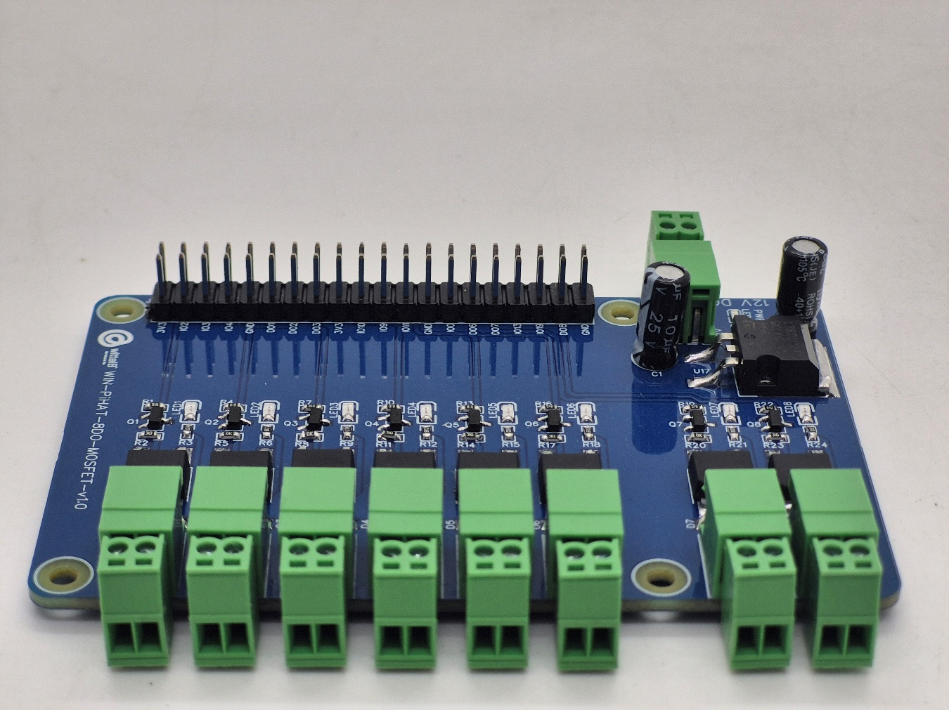
GND

OUT7

OUT5

OUT3

OUT1

- All 8 DO channels operate as MOSFET-driven digital outputs and are interfaced to the Raspberry Pi GPIO header through a Bipolar Transistor (BJT) driver stage. Output control is performed via software running on the Raspberry Pi. Each channel is configured as a GPIO output and drives a corresponding High-Side MOSFET switch.
- When a GPIO pin is driven HIGH, the Bipolar Transistor pulls the MOSFET Gate LOW, turning the channel ON and supplying power to the load. When the GPIO pin is driven LOW, the MOSFET turns OFF and the output returns to its default state.

Digital Output Characteristics:
- The DO pin is a high-side output and reflects the input supply voltage.
- Example: Supplying 24V will result in a 24V output, which can damage 12V-rated relays. Ensure compatibility with the load.

Sample Test Code:
- WIN-PiHAT-8DO(MOSFET)
Hardware Interface & Connector Layout:
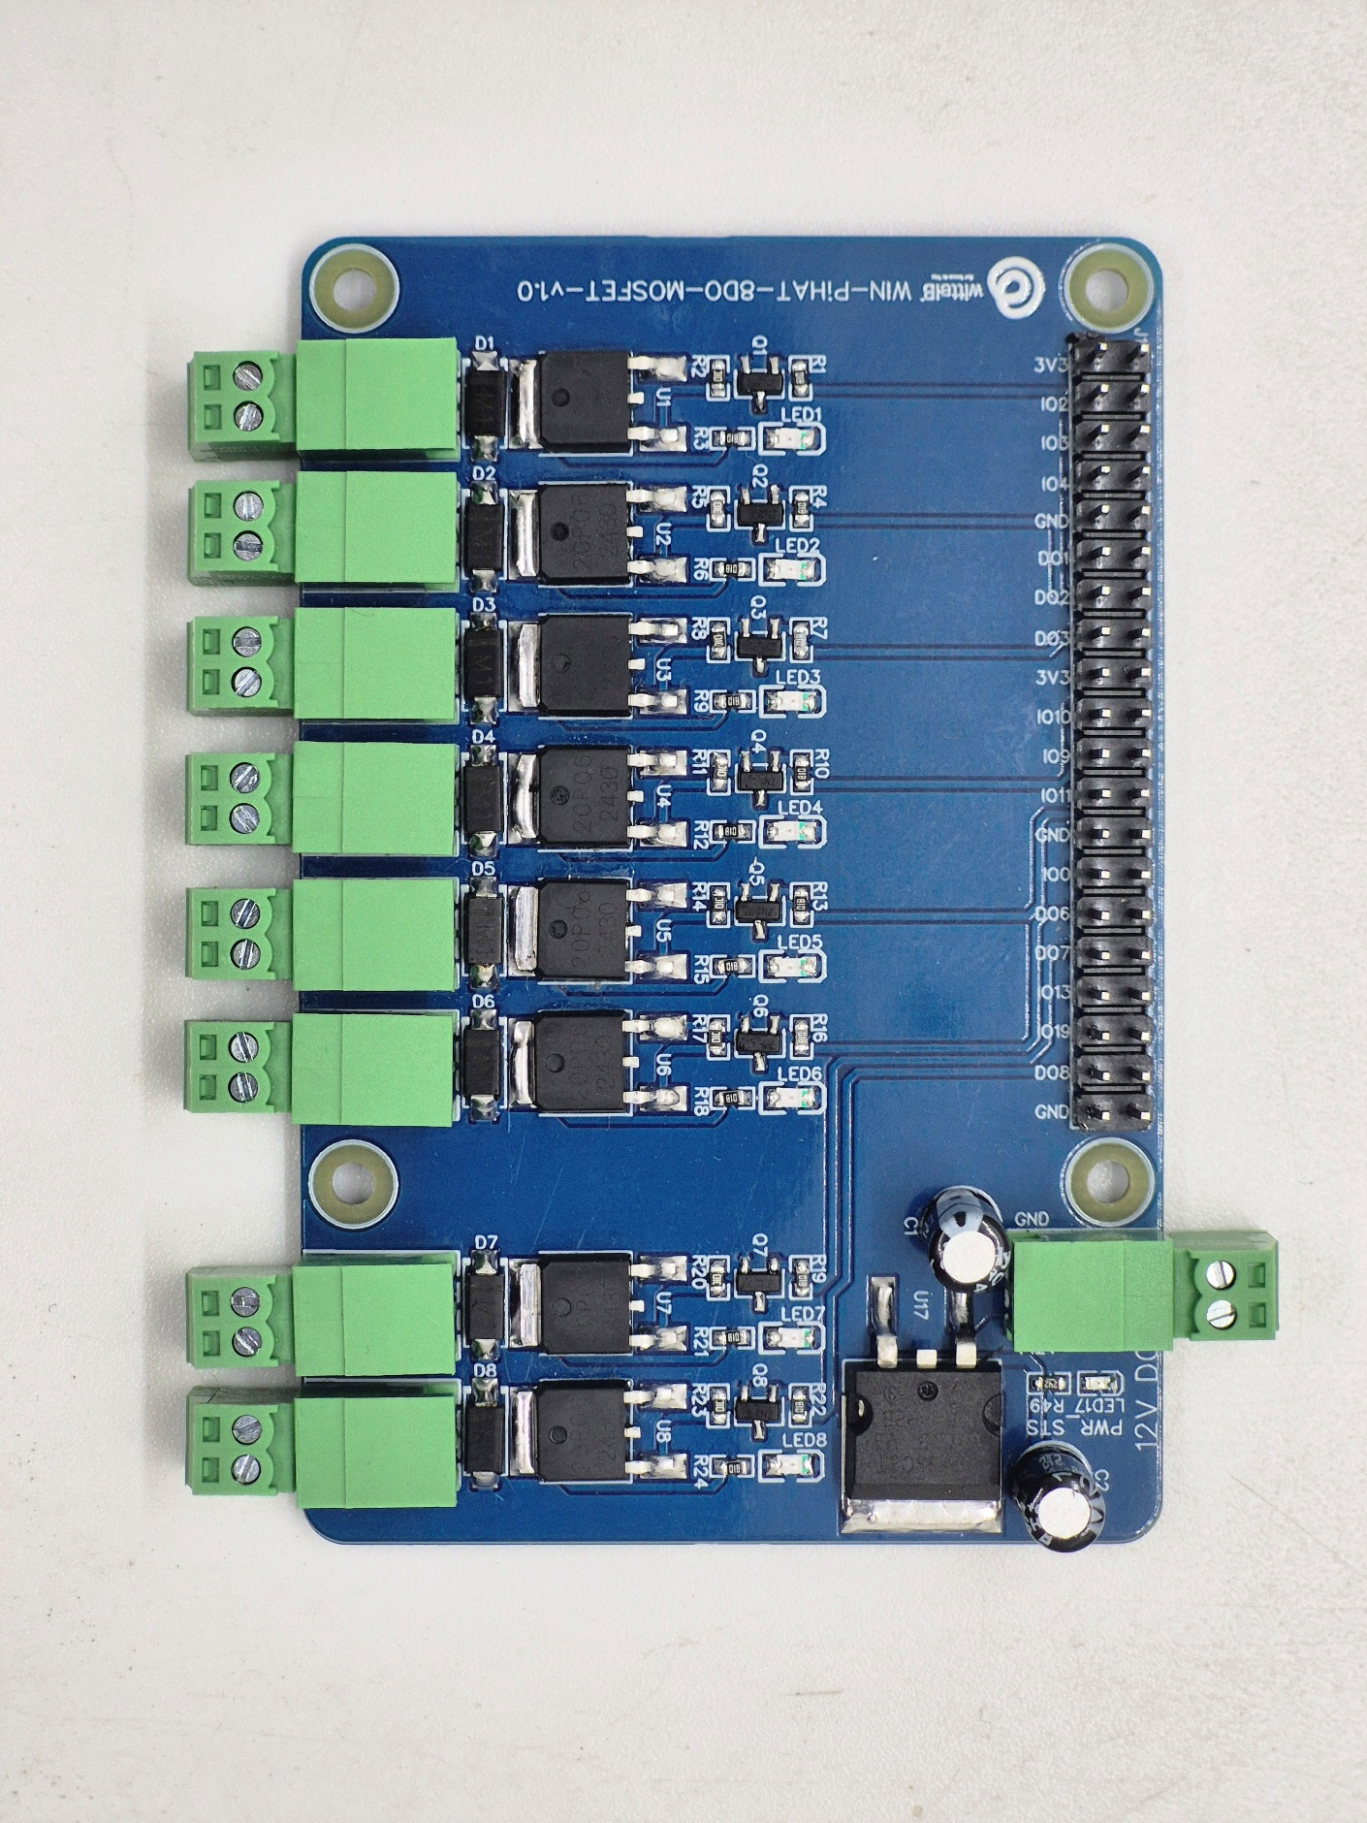
40 pin GPIO Headers
GND
12/24V DC Supply
OUT1 – OUT8

2
1
40
39

Contact us: -
Augmatic Technologies Pvt. Ltd.,
Plot no 6, Shah Industrial Estate II,
Kotambi,
Vadodara – 391510.
Email – Sales@wittelb.com

